**Steps to mount Google Drive and link Datasets on Google Colab**

1. Mount the google drive on google colab
   1. Click on mount drive icon

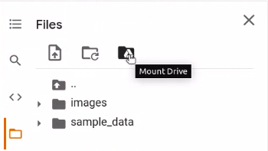

* 1. Click on connect to Google Drive

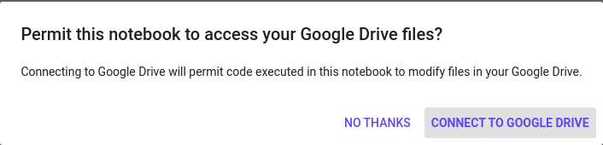

* 1. After connecting successfully it will appear like this

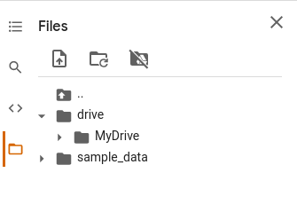

1. Click on the link you received for the masterclass folder in your mail

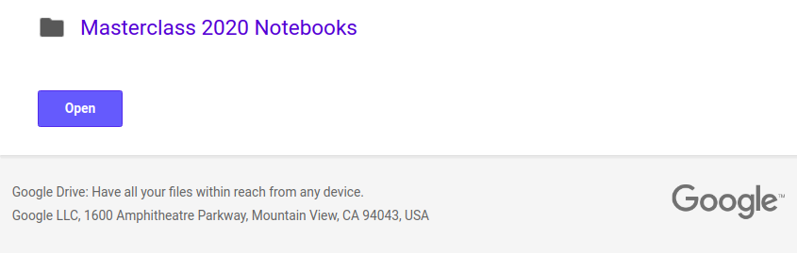

1. Add shortcut of the masterclass folder shared with you on the drive
   1. After opening it will appear like this

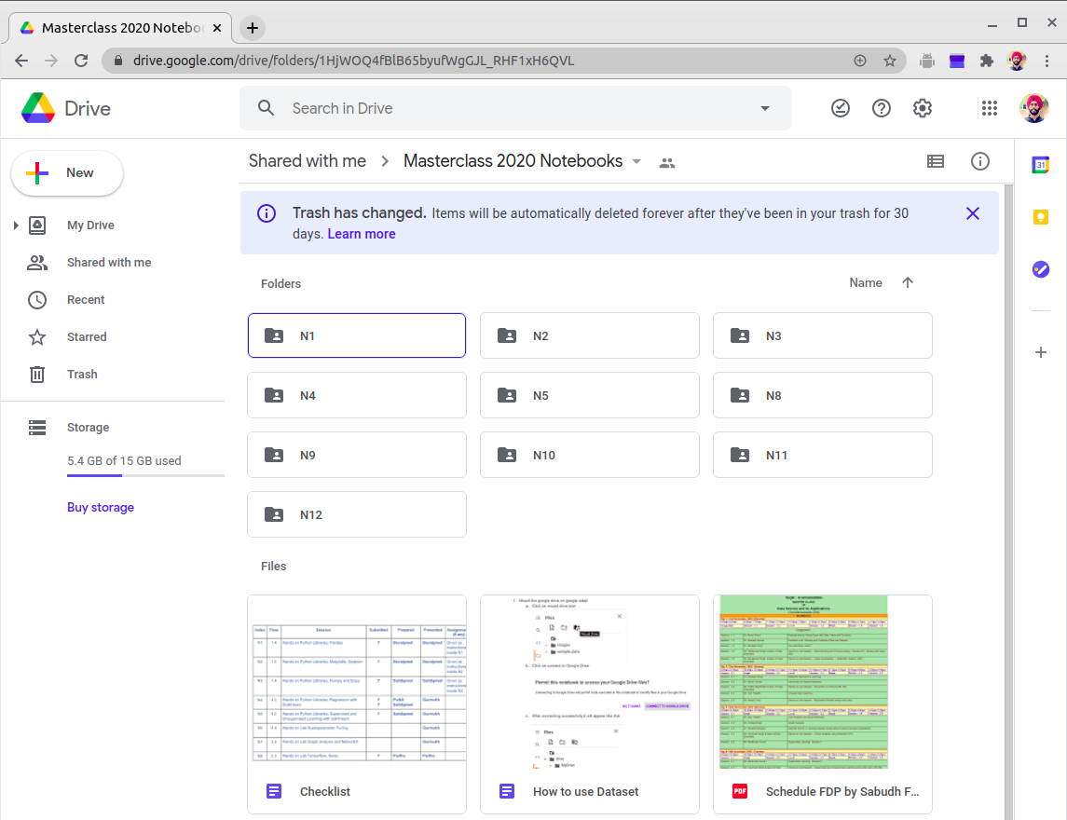

* 1. Click on Masterclass 2020 Notebooks it will something like this as shown below

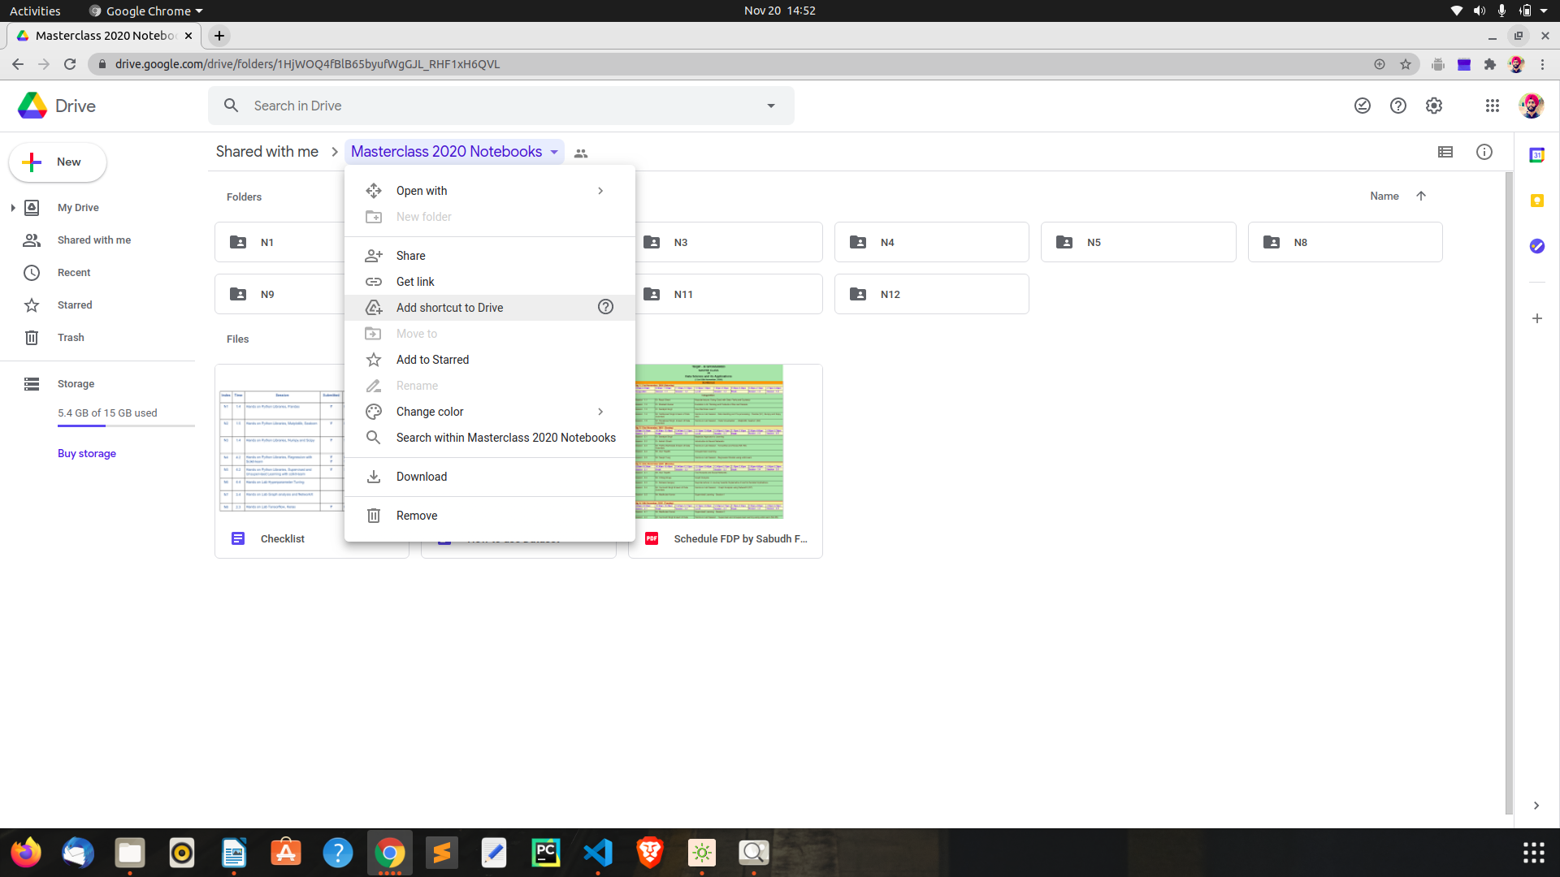

* 1. Click on Add shortcut to Drive then select My Drive

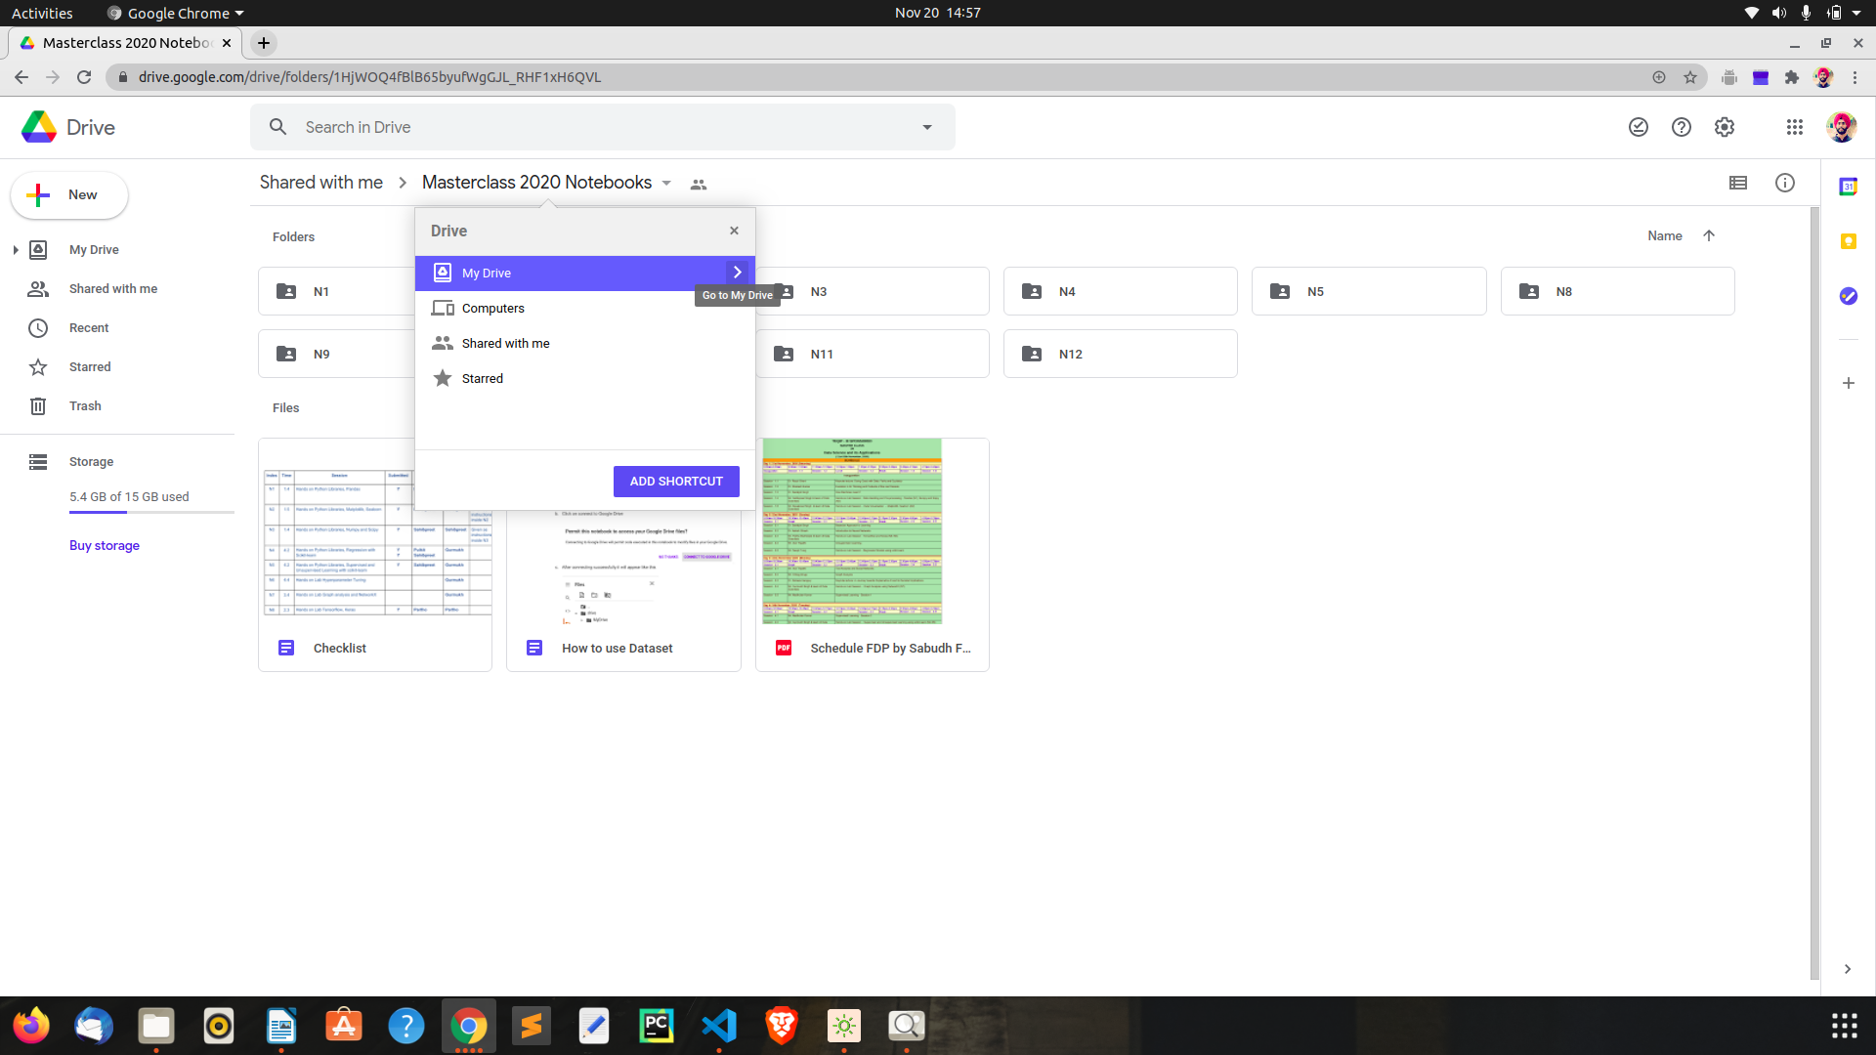

* 1. Click on the Add Shortcut button(after clicking you will see a dialogue box coming on bottom left showing Shortcut added to “My Drive”.

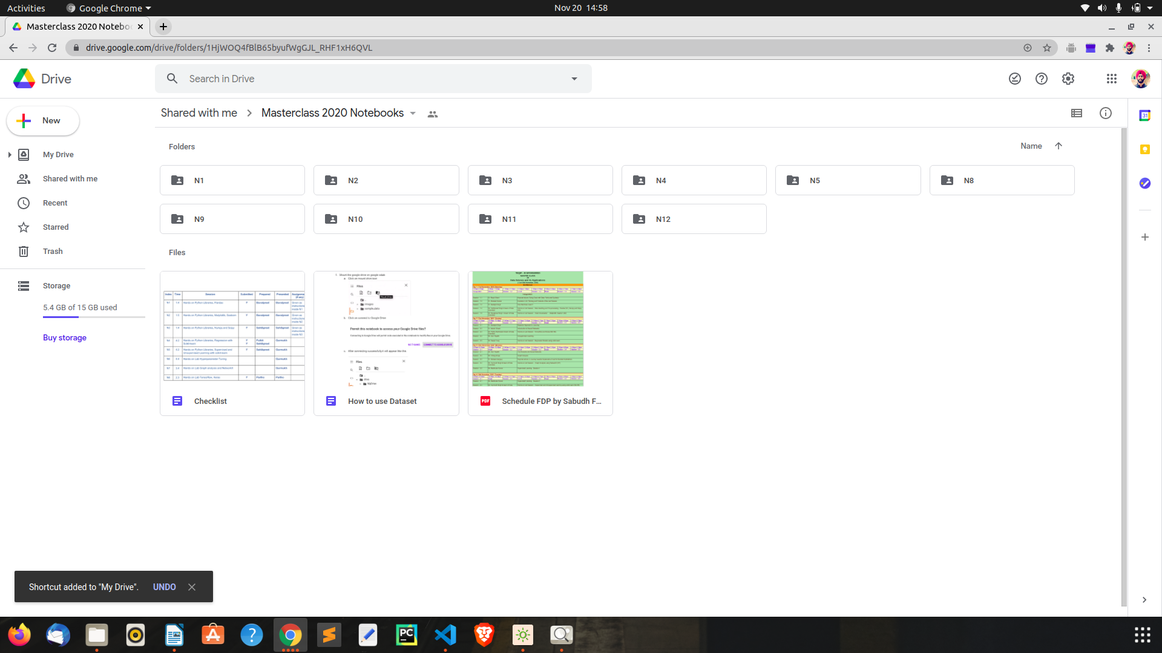

1. Locate the link to dataset associated with a specific notebook from drive via colab
   1. Click on the folder button followed by drive then by MyDrive then in MyDrive locate Masterclass 2020 notebook.

Folder button---> Drive ---> My Drive --->Masterclass 2020 notebook

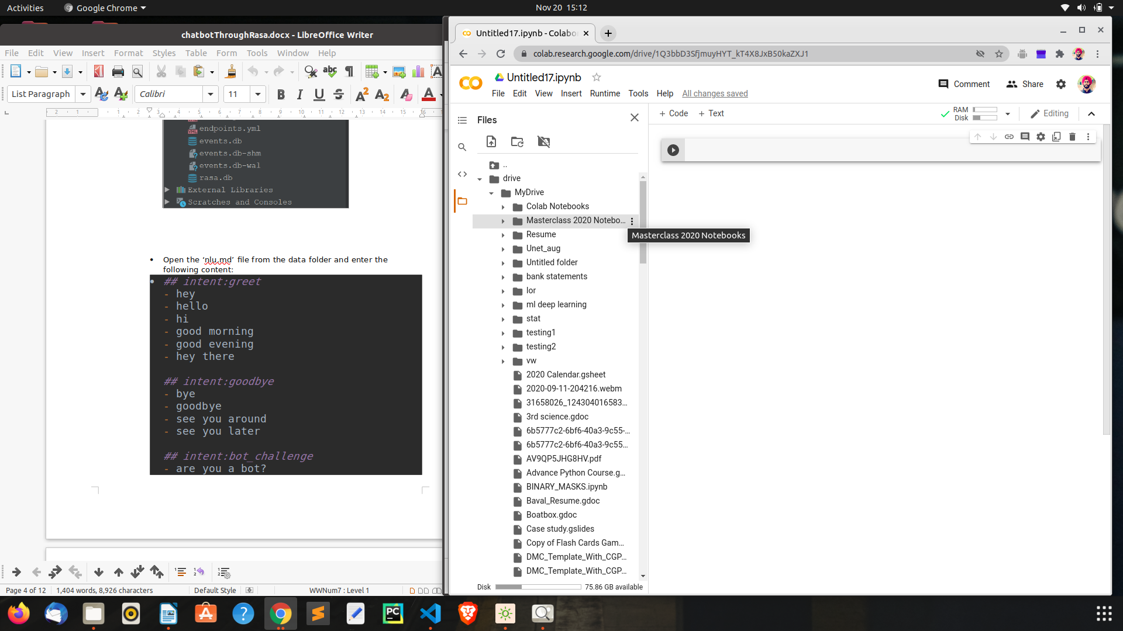

* 1. Now go inside the Masterclass 2020 notebook folder and open desired folder for eg N1 here

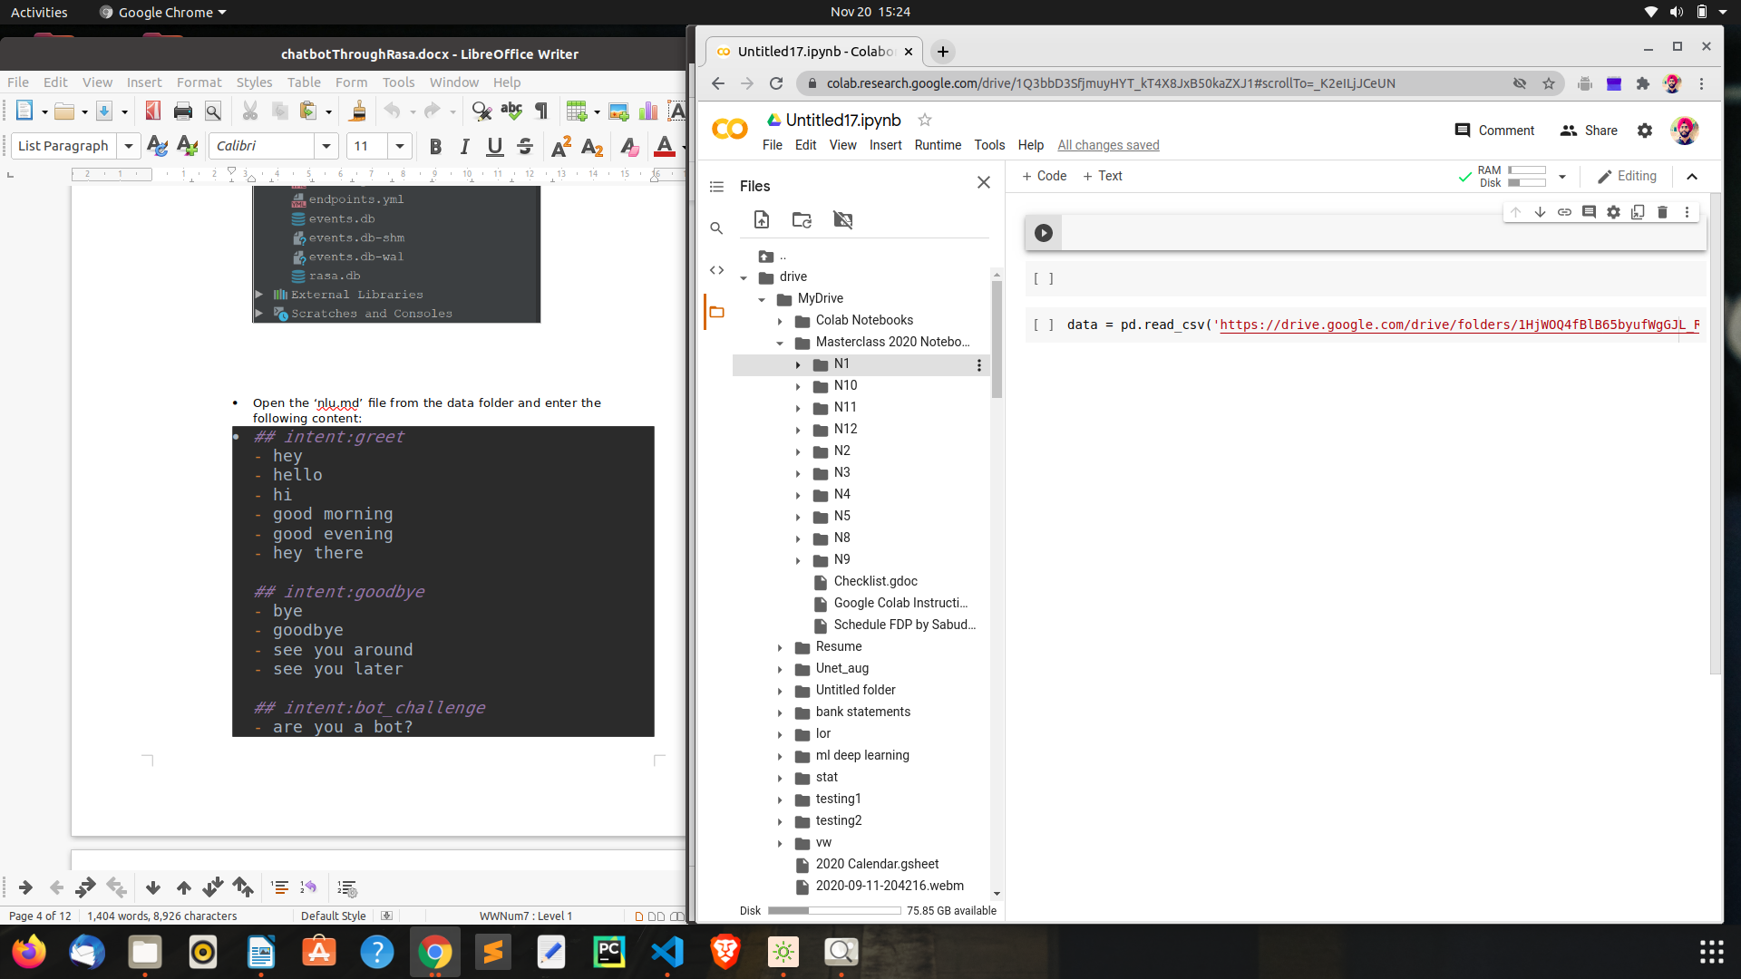

* 1. After opening the notebook (N1 here) folder You will see the Dataset for that specific notebook.

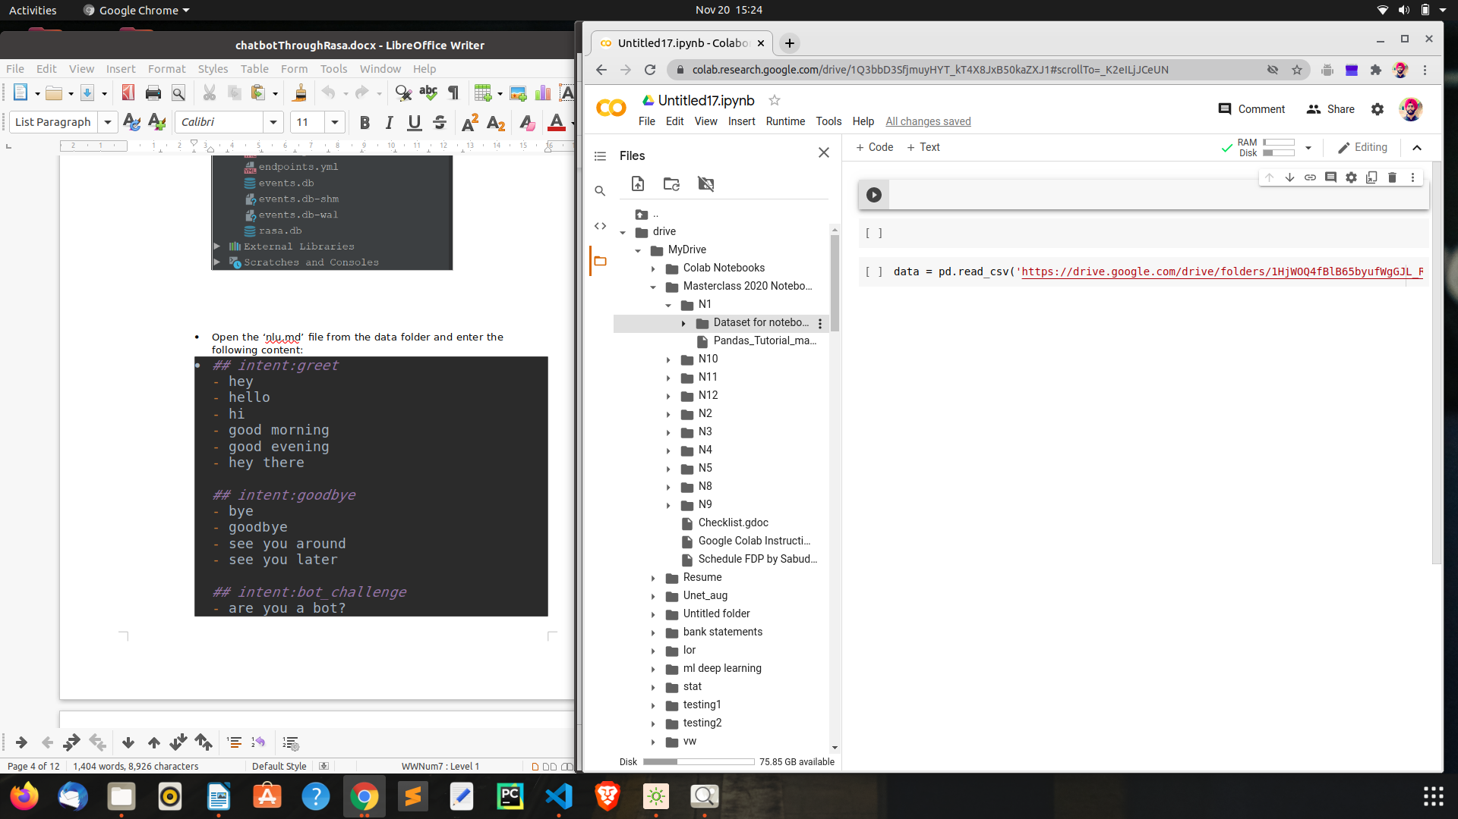

* 1. Copy the path of the dataset and paste as Shown below



1. That’s it we are done with colab setup.